# *Project Documentation of Sanitizer* *Monitoring App using AI*

1) Sanitization Monitoring in Co-working spaces using AI

2) Introduction

2.1) Overview

It is a sanitization monitoring app which is made with intent of usage in corporate offices, public departments, commercial buildings, government departments etc.

It is used as it will made a time to time record of proper sanitization in various rooms or departments of co-working places.

2.2) Purpose

It is made with the purpose of effectively monitoring proper sanitization of co-working spaces.

3) Result

The results are at par as expected to our expectations.

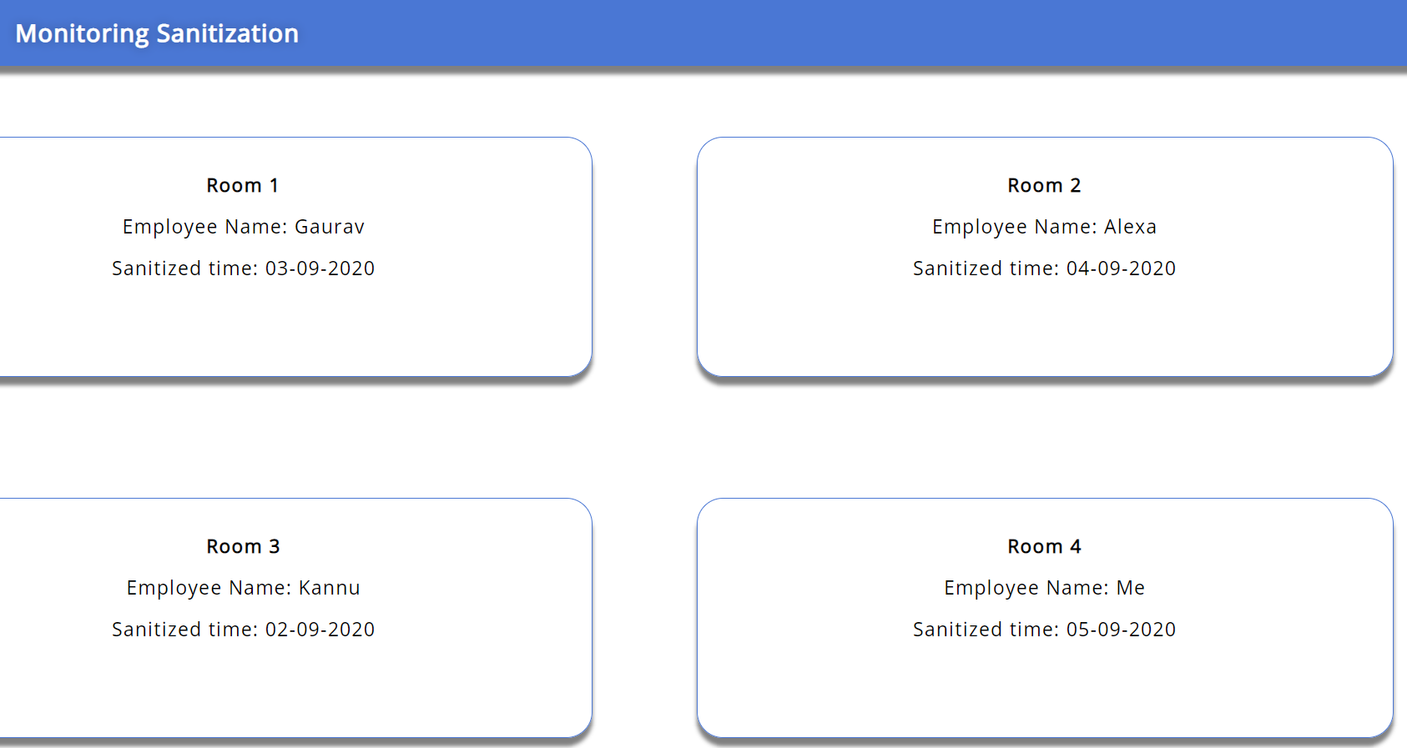

Fig- 1.1: Sanitization Monitoring Web App

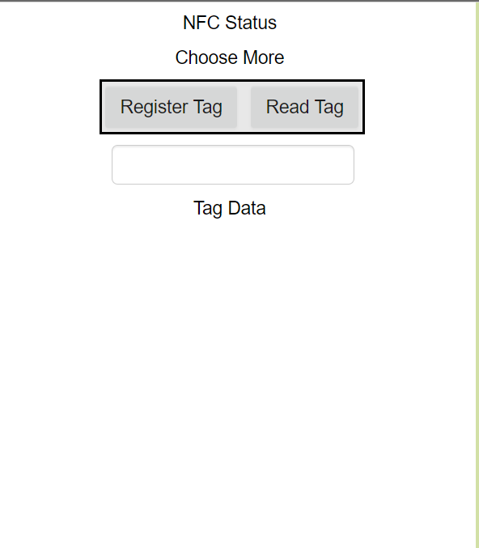

Fig- 1.2: Sanitization Monitoring Mobile App Screen

4) Applications

The app has various applications not only for the sanitization purpose, although, it has been made for sanitization purpose but it can also be used in offices to take attendance of the employess in place of biometrics.

As the employees are wearing these wearable bands and when they will enter in the office they have to mark their attendance by showing their bands near to the NFC tag and their attendance will be marked with their names with date and time.

5) Conclusion

So the conclusion is that with AI and IoT nowadays are becoming more and more useful these days and also things are becoming easy and automated nowdays in which AWS is providing these services free of cost*.

6) Future Scope

In future AI and IoT will play a major role in our lives and also in our surroundings.

Things will become automated with the help of AI and IoT.

Also many companies are working on this platform and near education sector will also provide these services in the curriculum.